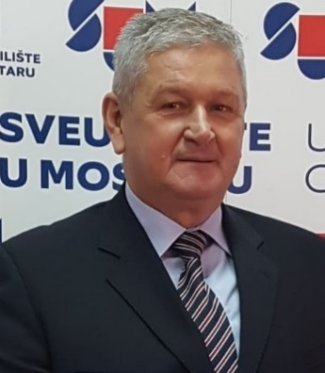
Dragan Babić
Professor, MD, PhD

Bosnia and Herzegovina

Specialist in Neuropsychiatry, subspecialist of Social Psychiatry, permanently employed at the Clinic of Psychiatry at the University Clinical Hospital Mostar, currently as the Head of the Department for Chronic Psychosis. Full professor at the Faculty of Medicine, Faculty of Health Studies, Faculty of Philosophy and Law, University of Mostar, where he holds the position of head of several departments in the field of psychiatry and psychology. Vice Dean for Science and International Cooperation (2013-2021) and Editor in Chief of the electronic journal Health Bulletin of the Faculty of Health Studies since 2014. Guest Editor of the Supplement for journal Psychiatria Danubina in 2017 and 2020. Educated at the Universities of Tuzla and Mostar, and trained in the Republic Croatia, Slovenia and Italy. He is one of the most prolific and published scientists at the University of Mostar. He has published four books and written 12 more chapters in books by other authors. He had lectures at numerous scientific conferences, symposia and congresses in the country and abroad. So far, he is author and co-author of over 170 professional and scientific papers published in domestic and international journals. Leader of several projects for which he received the support of the Federal Ministry of Science in B&H as well as a participant in several international projects. He is a mentor of 14 doctoral dissertations, over 70 master’ theses and over 250 final and graduate theses. He is actual President of the Psychiatric Association of Bosnia-Herzegovina and obtained same position in the Association in the period 2013-2014. President of the Organizing Committee of the International Symposium Mostar Psychiatric Saturday from 2003 to 2022, and the President of the Organizing Committee for Bosnia and Herzegovina of the 23rd Danube Symposium held in Mostar in 2008. He completed numerous educations in the field of psychiatry: psychotraumatology, addictions, suicidality, group psychoanalysis. He is a member of the Croatian Academy of Sciences and Arts of Bosnia and Herzegovina and member of International Academy of Sciences and Arts in Bosnia and Herzegovina. He was born in Živinice (B&H) on June 10, 1958. Married, lives in Mostar with his wife and two children.

