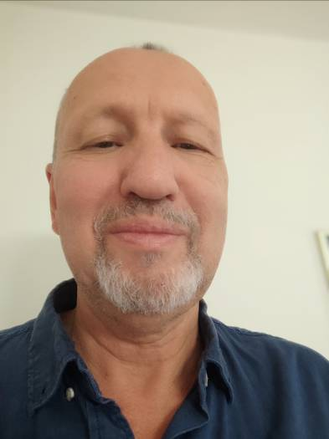
Edin Bjelošević
Associate Professor, MD, PhD

Bosnia and Herzegovina

Born on 28.06.1957 in Zenica. He graduated from the Faculty of Medicine, University of Sarajevo in 1984. He completed his Master (MD) studies on 2003 and his Doctoral (PhD) studies on 2010. He has been an Associate Professor since 2018. He has completed a number of various trainings in psychiatry and mental health. He has been the Head of the Child and Adolescent Psychiatry Team at the Center for Mental Rehabilitation in the Health Center Zenica since 2015 and the Head of the Department of Neuropsychiatry at the Faculty of Health, University of Zenica since 2011. He has participated in the efforts of the Commission for the establishment of the Faculty of Health and the Faculty of Medicine, University of Zenica. He is one of the founders of the Centre for Mental Rehabilitation and the Institute for Addictions Zenica. He is a professor and an organizer of numerous preventive programs and projects for mental health professionals, general practitioners, nurses, educational workers, the employees of the Ministry of Internal Affairs and elementary and secondary school students. He is the supervisor of 65 graduate papers and eleven master theses, and a co-supervisor of one doctoral thesis. He is the author of several papers published in journals and presented on congresses. He published 7 books as an author or co-author. President and member of the Commission for obtaining specialist exam in Psychiatry for 10 candidates.

