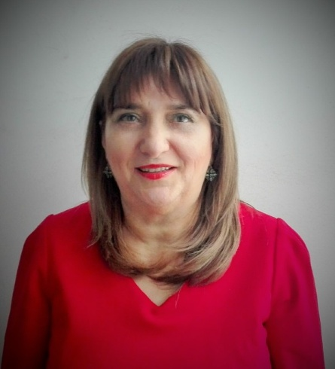
Marija Burgić-Radmanović
Professor, MD, PhD

Bosnia and Herzegovina

She has graduated at the Faculty of Medicine, University of Sarajevo (Bosnia and Herzegovina) and completed specialization in Neuropsychiatry as well as Bachelor in Child and Adolescent Psychiatry at the Faculty of Medicine, University of Zagreb (Croatia). Doctoral dissertation (PhD) finished at the Faculty of Medicine, University of Banja Luka (Bosnia and Herzegovina).
She is the founder of the Department for Child and Adolescent Psychiatry at the Clinic for Psychiatry, University Clinical Center of Republic of Srpska Banja Luka, whose head she was from its foundation in 2002 until 2021. She was the Director of the Clinic for Psychiatry (UCC RS Banja Luka) in the period 2006 – 2010.
She is Full Professor at the Department for Psychiatry, Faculty of Medicine University of Banja Luka.
She is a member of several psychiatric associations: Past President and actual Vice-President of the Psychiatric Association of Bosnia-Herzegovina, Past President of the Association for Child and Adolescent Psychiatry in Bosnia and Herzegovina, WPA Section for Education, Board for Cardiovascular Pathology of the Academy of Sciences and Arts of the Republic of Srpska as well as Medical Chamber of the Republic of Srpska.
She was invited lecturer on several national and international congresses, symposia and conferences, and published several scientific papers as well as several books from the field of Psychiatry as author or co-author. She is the mother of three children.

