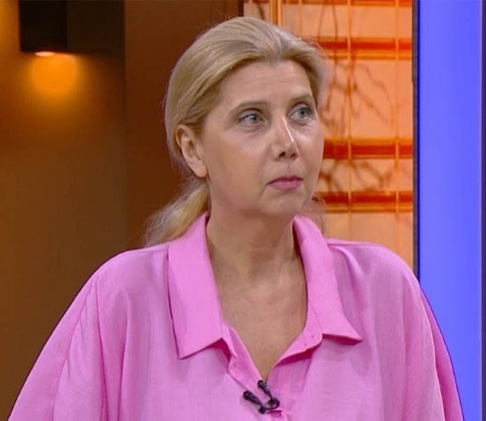
Eka Chkonia
Professor, MD, PhD

Georgia

She is Professor in Psychiatry at Tbilisi State Medical University (TSMU), Honorary Member of the World Psychiatric Association, Head of the Society of Georgian Psychiatrists, Program Director in Psychiatry (TSMU USMD program), Clinical Director at the Central Psychiatric Hospital (Tbilisi Mental Health Center), Editorial Board member of the journal “V.M.Bekhterev Review of Psychiatry and Medical Psychology”, Editorial Board member of the medical journal “The Georgian Psychiatric News”.
She is the Secretary of the Steering Committee of the EPA (European Psychiatric Association) Council of NPAs, Member of the EPA Ethics committee, Head of the WPA Expert Committee on the Ukrainian mental health crisis, Ambassador for Georgia in European College of Neuropsychopharmacology (ECNP, 2013-2017).
She teaches General and Clinical Psychiatry to the TSMU medical students, coordinates the courses in Human Development and Neuroscience (TSMU USMD program). She is a Director of the Clerkship in Psychiatry (TSMU USMD program).

