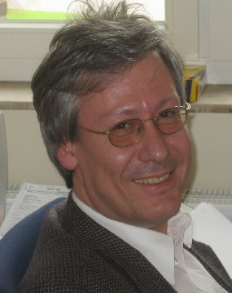
Jürgen Deckert
Professor, MD, PhD

Germany

Born 1958 in Würzburg (Germany) he is married with two children. He graduated in human medicine, Julius-Maximilians-University Würzburg. He trained as assistant physician and consultant psychiatrist, Department of Psychiatry, Julius-Maximilians-University Würzburg and assistant physician, Department of Neurology, Ruhr University Bochum. His research rotations were as research fellow at the Unit on Neurochemistry, Biological Psychiatry Branch, NIMH, Bethesda, MD, USA and as research associate at the Institute of Human Genetics, Friedrich-Wilhelms University Bonn. After the habilitation in psychiatry, he was Vice Director of the Department of Psychiatry and Psychotherapy and Professor of Molecular Psychiatry at Wilhelms-University Münster. From 2006 on he is Professor and Chairman, Department of Psychiatry, Psychosomatics and Psychotherapy, Julius-Maximilians-University Würzburg. He participated in numerous research consortia, e.g. was in the steering committees of psychotherapy trials (PanicNet 1 and 2, Protect-AD), PI and site speaker of the CRC TRR 58 Fear, Anxiety and Anxiety Disorders. Currently, he is speaker of the Center of Mental Health and the Comprehensive Anxiety Center, member of the Executive Board of the Comprehensive Heart Failure Center and the Center of Rare Diseases, all at the Julius-Maximilians-University Würzburg. He is speaker of the Mental Health Working Group of the German COVID-19 university medicine network and cochair of the PGC Anxiety. He was invited speaker at numerous international scientific events, was or is involved in editorial boards of JNT, IJNP, ADHD, Danubina and other scientific journals and is active in relevant national and international associations. He published more than 200 scientific papers and is cited more than 6000 time (h index = 40).

