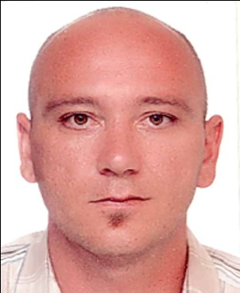
Sandi Dizdarević
Assistant Professor, PhD
Bosnia and Herzegovina
Born on February 13, 1981. in Tuzla (Bosnia and Herzegovina), married and father of two daughters. He completed primary and secondary school in Banovići (BH), and graduated and obtained master's degree at the Faculty of Criminology, Criminology and Security Studies of the University of Sarajevo (BH). He completed his doctoral studies at the University of Modern Sciences, CKM Mostar (BH) and obtained the title of Doctor of Security Sciences, narrow field of criminological police studies. Main field of interest: interviewing techniques, criminal psychology, radicalism, extremism and terrorism. In a professional sense, he held the following positions: criminal police investigator, prosecutor's investigator in the War Crimes Department, currently holds the position of Chief Commander of the Prison police. In the course of his professional career, he devoted special attention to the detection, investigation and proof of criminal acts of stabbing, and in the course of his police-judicial career, he was a member of the team that solved 49 criminal acts of murder and participated in the examination of more than 3,000 witnesses. In 2019/2020, he was elected to the position of Assistant Professor at the Department of Legal and Security Sciences, University of Modern Sciences CKM Mostar, where he teaches Criminal Psychology, Criminal Interview, Criminology, Methods of Detection, Research and Proving of Blood and Sexual Crimes, Protection from Terrorism.
He is the author of more than 50 scientific papers, a participant in more than 30 police-intelligence-judicial trainings in the field of prosecuting criminal offenses with fatal consequences, interviewing techniques, and counter-terrorism. He is a trainer for the training of police investigators in the field of interviewing techniques and tactics. Visiting Professor at several faculties in Bosnia and Herzegovina and the region as well. So far, he has published five original scientific works-books and one criminal victimological novel.

