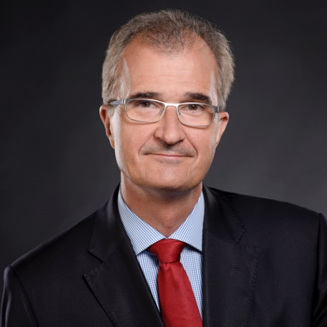
Peter Falkai

Professor, MD, PhD

Germany

He has been working in the field of psychiatry for 30 years. His main research interest is focused on the neurobiology of psychotic disorders, namely schizophrenia. He holds the position of Chair of the Department of Psychiatry and Psychotherapy of the University of Munich.
Prof. Falkai has been leading multidisciplinary teams of researchers, allowing the use of techniques ranging from functional imaging to gene expression in human post-mortem-tissue. His clinical and research expertise focuses continuously on the neurobiological origins and pathomorphological aspects as well as on causal treatment options of psychotic disorders.

