Trpimir Glavina
Professor, MD, PhD

Croatia
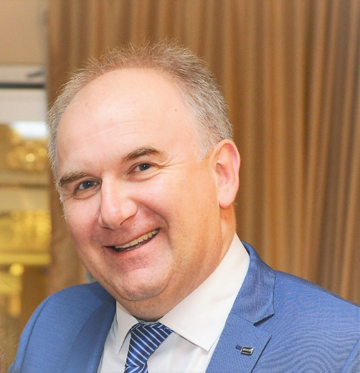
Born in Split, Republic of Croatia, in 1963. Married, father of two children. A graduate at the Faculty of Medicine, University of Zagreb in 1988. Had been working within Family and School Medicine prior to permanent employment at the Psychiatric Clinic of the Clinical Hospital Centre Split (CHC Split) in 1991. Defended Master’s Thesis on Forensic Psychiatry topic and Doctoral dissertation on Biological Psychiatry topic. Acquired the title of Primarius and subspecialist of the biological and forensic psychiatry. He is Head of the Clinical Hospital Centre Split Psychiatry Clinic since 2015 and the Head of the Department of Psychiatry at the Faculty of Medicine, University of Split since 2016, a second term at the moment. Likewise, the Head of the Professional postgraduate study in Psychiatry at the Faculty of Medicine, University of Split.
Participant in the classes at the Faculty of Medicine in Split (Medicine, Medicine in English, Dentistry, Pharmacy), Forensic Studies in Split, professional postgraduate doctoral studies at the Faculty of Law in Split, University Department of Health Studies in Split, postgraduate Probation Studies at the Faculty of Philosophy in Split and the Catholic Faculty of Theology in Split. The mentor and examiner of the psychiatry residents and subspecialists in forensic and biological psychiatry, and member of the thesis defense expert committees, as well as mentor of the numerous Masters graduates. Appointed by the Ministry of Health of the Republic of Croatia as the leading mentor for the psychiatry residents at KBC Split. The head of the Reference Center of the Ministry of Health of the Republic of Croatia for long-acting antipsychotics. The president of the Croatian Psychiatric Association Ethics Committee at present and former member of the Ethics Committee of the Faculty of Medicine in Split in two terms. The member of the Board of Directors of KBC Split since 2016, elected by the Expert Council, and member of the National Commission for Psychiatry of the Republic of Croatia and the working group for psychiatry training. The lecturer and the participant of the many organizational and scientific committees of the congresses, symposiums and conferences in the country and abroad. Author and co-author of a number of the articles published in the indexed journals and other publications. Reviewer, collaborator or author in several studies and books in psychiatry. Fluent in English. One of the founders of the choir "Splitski liječnici pjevači" (1988), a former soccer player and an active veteran of the “Splitski liječnici balunjeri”. Particularly interested, apart from biological and forensic psychiatry, in a holistic and comprehensive approach to psychiatry using sociological, philosophical and anthropological premises.

