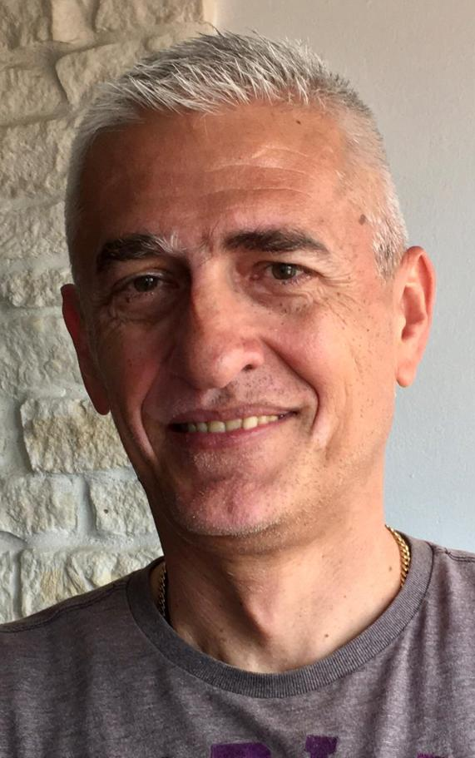
Davor Lasić
Associate Professor, MD, PhD

Croatia

Born on February 1, 1967. in Split (Croatia), married, father of three children. Graduated at the Faculty of Medicine, University of Zagreb in Split on 1990. Since 1994 has been employed at the Department of Psychiatry, Clinical Hospital Centre Split. He has been a specialist in Psychiatry since 2000. and a subspecialist in Biological Psychiatry since 2013. In 2014 defended PhD dissertation at the School of Medicine, University of Mostar under the mentorship of Professor Miro Jakovljević and the commentary of Ass. Professor Ozren Polašek. From 2021 he is elected to scientific-teaching position of Associate Professor at the School of Medicine, University of Split. He is Head of the Department of Clinical Psychiatry with Child and Adolescent Psychiatry at the Department of Psychiatry, Clinical Hospital Centre Split.

