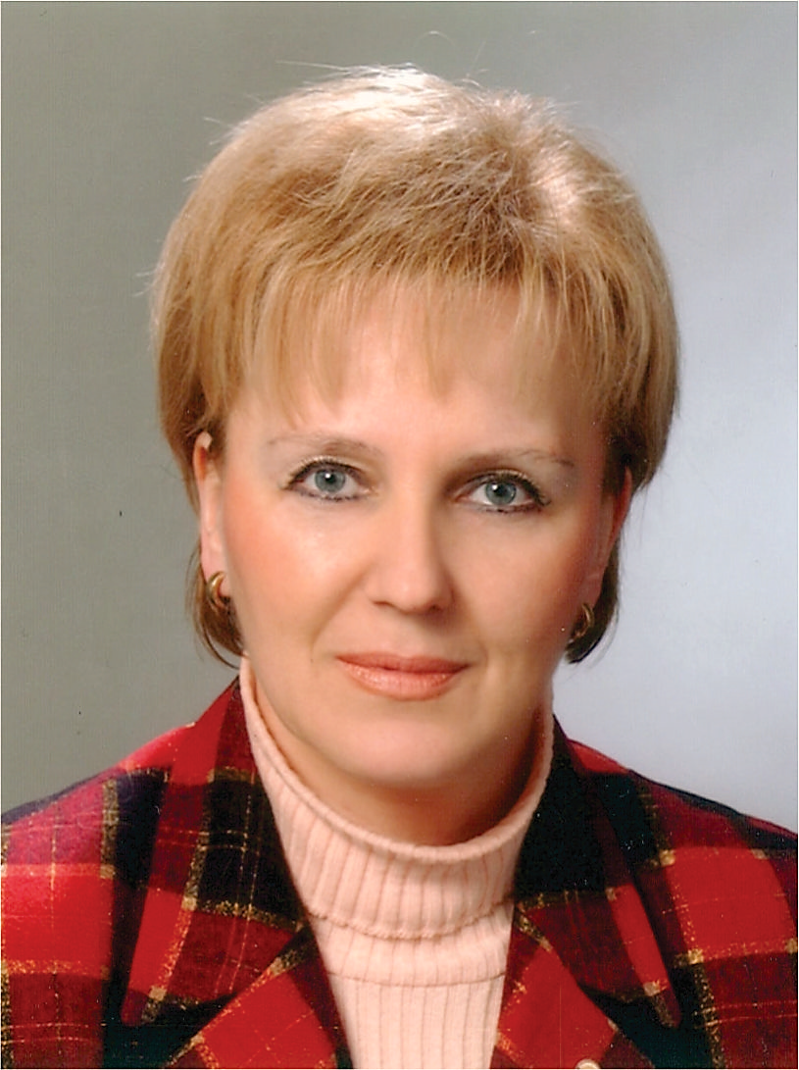
Nermana Mehić-Basara
Assistant Professor, MD, PhD

Bosnia and Herzegovina

She is Neuropsychiatrist, Subspecialist for Addiction Diseases, Director of the Institute for Addiction Diseases of the Sarajevo Canton (until 2022), Assistant Professor at University of Sarajevo, Faculty of Health Studies (until 2021). Born 1957 in Sarajevo (Bosnia and Herzegovina), graduated at the Faculty of Medicine of the University of Sarajevo in 1981 and passed specialization exam of Neuropsychiatry 1989 in Sarajevo. At the Faculty of Medicine of the University of Sarajevo, 2007 defended master's thesis "Effects of Methadone Treatment on Opioid Addicts and 2012 doctoral dissertation on topic "The association of dopamine receptor gene polymorphism and psychological personality traits in development of opiate addiction”
She spent the war time from 1992-1995 in the besieged Sarajevo and was actively involved in the work of teams for psychological assistance and support for domicile population and refugees. From 1995 - 2015, she has been a Coordinator on Addictions of Federation of Bosnia and Herzegovina in front of the Federal Ministry of Health for WHO. From 1997 to 2003 she was a Coordinator for the Project "Community Mental Health", which made a significant contribution to the implementation of Mental Health System Reform in BH with orientation to community psychiatry. She has given special contribution to revitalization of Institute for Addiction Diseases in infrastructure renewal as well as in establishing modern substitution treatments programme for addicts which were comparable with reforms goals. In the year 2003, she was a member of the founding group of the Association of South-East European addictologists (South –East European Addiction Network) and from 2005 to 2007 she was the president of this Association.
In the year 2004, awarded with the prestigious "Nyswander-Dole Marie Award" by the American Association for Treatment of Opiate Addiction (AATOD) for achievement in treatment of addicts in B&H. Since 2007 she is a member of the European Association for the treatment of opiates (EUROPAD - European Opiate Addiction Treatment Association).
From 2007-2012, she was the president of the Expert Team for the Development and Implementation of the „Program for Monitoring, Prevention and Treatment of Demobilized Soldiers and their Family Members suffering from PTSD in Sarajevo Canton “. In the post-war period, she was a member of the Expert group for developing the State Strategy for Suppression of Addictions and Revised Policy and Mental Health Strategy in BiH.
Actively participated in more than 60 local, regional and international professional conferences, has been the organizer of several mental health conferences, member of the Organizing Committee of the First (2003) and the Second (2007) Congress of Psychiatrists of Bosnia and Herzegovina as well as a member of the Congress Committee of the Third (2012) and Fourth (2017) Congress of Psychiatrists of BH. Up to now, she published over 40 scientific and professional papers in the field of addiction, community mental health and posttraumatic stress disorder in relevant scientific journals. As author and co-author, she has participated in the development of large number of professional guides, manuals, textbooks and other publications from above mentioned fields.

