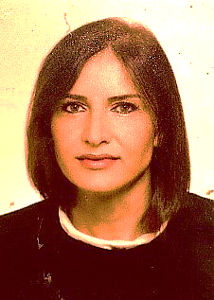
Amra Memić-Serdarević

Associate Professor, MD, PhD

Bosnia and Herzegovina

Employed at the Clinic of Psychiatry, Clinical Center University of Sarajevo as a specialist neuropsychiatrist and a Associate Professor at the Department of Psychiatry and Medical Psychology of the Faculty of Medicine of the University of Sarajevo.
In addition to clinical work, she is engaged in scientific research in the areas of clinical and biological psychiatry and psychiatric genetics. She is the author and co-author of a large number of scientific and professional works. She participated in many domestic and international scientific research projects. She also participated in numerous congresses, symposia and conferences as an active participant and invited lecturer, as well as in educational schools
and trainings.
She defended her master's thesis at the Faculty of Medicine of the University of Sarajevo. Doctoral thesis in the field of psychiatric genetics, under the mentorship of Prof. Ph.D. Marcella Rietschel, was prepared and defended at the Psychiatric Clinic of the Clinical Center University of Sarajevo, the Faculty of Medicine of the University of Sarajevo, the Psychiatric Clinic of Mannheim (Germany) and the Faculty of Medicine of the University of Heidelberg (Germany).

