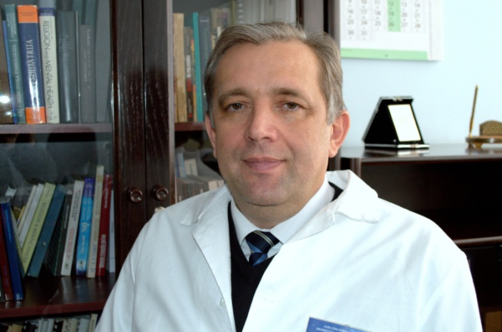
Izet Pajević
Professor, MD, PhD

Bosnia and Herzegovina

He is specialist in neuropsychiatry,
subspecialist in clinical psychiatry, group analyst, supervisor and educator in group analysis. Born on 1959 in Tuzla, where he completed Elementary school and Mathematical Gymnasium. He studied Medicine at the School of Medicine at the Universities of Tuzla and Sarajevo. Upon his graduation he got a job at the Department for Psychiatry in Tuzla, and he is currently a Head of the Department. In 1993 he completed specialization in neuropsychiatry. During the 1995 he spent a study tour at the University of Missouri - Columbia (USA) in the field of trauma psychology. From 1998 to 1999 he was trained in supervision (University of Goetheborg). In addition, he attended a Diploma Course in Group Analysis from 2002 to 2009 and from 2009-2013 he completed education for group analysis educator (given by Institute of Group Analysis, Zagreb). He received his Master’s degree in the "Islamic way of life as a factor of mental stability" from the School of Medicine University of Tuzla in 1999, and a PhD with his dissertation on "The impact of religiosity on mental health in adolescents” in 2003. After completing his PhD, Izet was elected as Assistant Professor at the School of Medicine, University of Tuzla, where he lectured Neuropsychiatry with Medical Psychology. Since 2008 he is Associate Professor, and full time Professor title he gained in 2015, and he teaches Psychiatry with Medical Psychology. Also, at the Tuzla University he teaches: Psychology of Communication and Social psychiatry within the undergraduate courses. Also, he teaches postgraduate courses in Clinical Research at the School of Medicine, University of Tuzla. He gained a title Primarius in 2003, and he is a board-certified sub-specialist in Clinical Psychiatry (MoH, 2011). His clinical and research interests include the Clinical and Biological Psychiatry, Psychopharmacology, Child and adolescent psychiatry, Neuroscience, Psychotherapy, Psychoanalysis, Psycho-traumatology, Spiritual and Integrative medicine, and Psychology of spirituality and religion. He participated actively on the numerous national and international professional and scientific meetings. He has published over 200 scientific and professional papers. He is the author of several book chapters and editor of several books in the fields of his daily activities. He is member of World (WPA) and European (EPA) Psychiatric Associations. He served as the President of the Psychiatric Association of Bosnia-Herzegovina (PABH) in two terms. He currently serves as the President of the Association of Child and Adolescents Psychiatrists in Bosnia and Herzegovina and Associations of Psychiatrists of Tuzla Canton, the Vice-President of Association for Integrative Medicine in Bosnia and Herzegovina, and he is a PABH Presidency member and member of Group Analysts Association in Bosnia and Herzegovina. He lives in Tuzla, he is married and father of four children.

