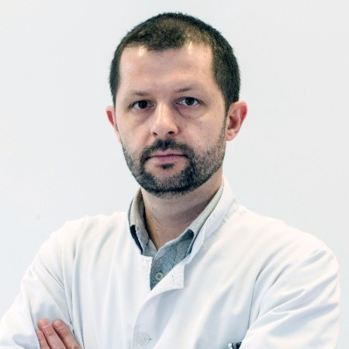
Marko Pavlović
MD, Phd

Bosnia and Herzegovina

He graduated at the School of Medicine, University of Zagreb (Croatia) in 2002. Training in Psychiatry obtained in University Clinical Hospital Mostar (BH) and the Psychiatric Hospital Vrapče Zagreb (Croatia) where passed exam in Psychiatry in 2010. Obtained MSc title in 2013 and PhD title in 2021, both at the Faculty of Medicine, University of Mostar. From 2010 works in the Department for Urgent Psychiatry and Intensive Psychiatric Care at the Clinic for Psychiatry, University Clinical Hospital Mostar.
He is Senior Clinical Assistant in the Department for Psychiatry at the Faculty of Medicine, University of Mostar. He is Assistant Editor of the e-journal „Zdravstveni glasnik“of the Faculty of Health Sciences at the University of Mostar.
He was attending on numerous congresses and symposia in Bosnia and Herzegovina and abroad. Published more than 10 Congresses abstracts in supplements of international journals and 27 professional and scientific papers in indexed journals (12 in CC). Co-author of few university manuals from the field of Psychiatry and Medical Psychology. Married, father of two children.

