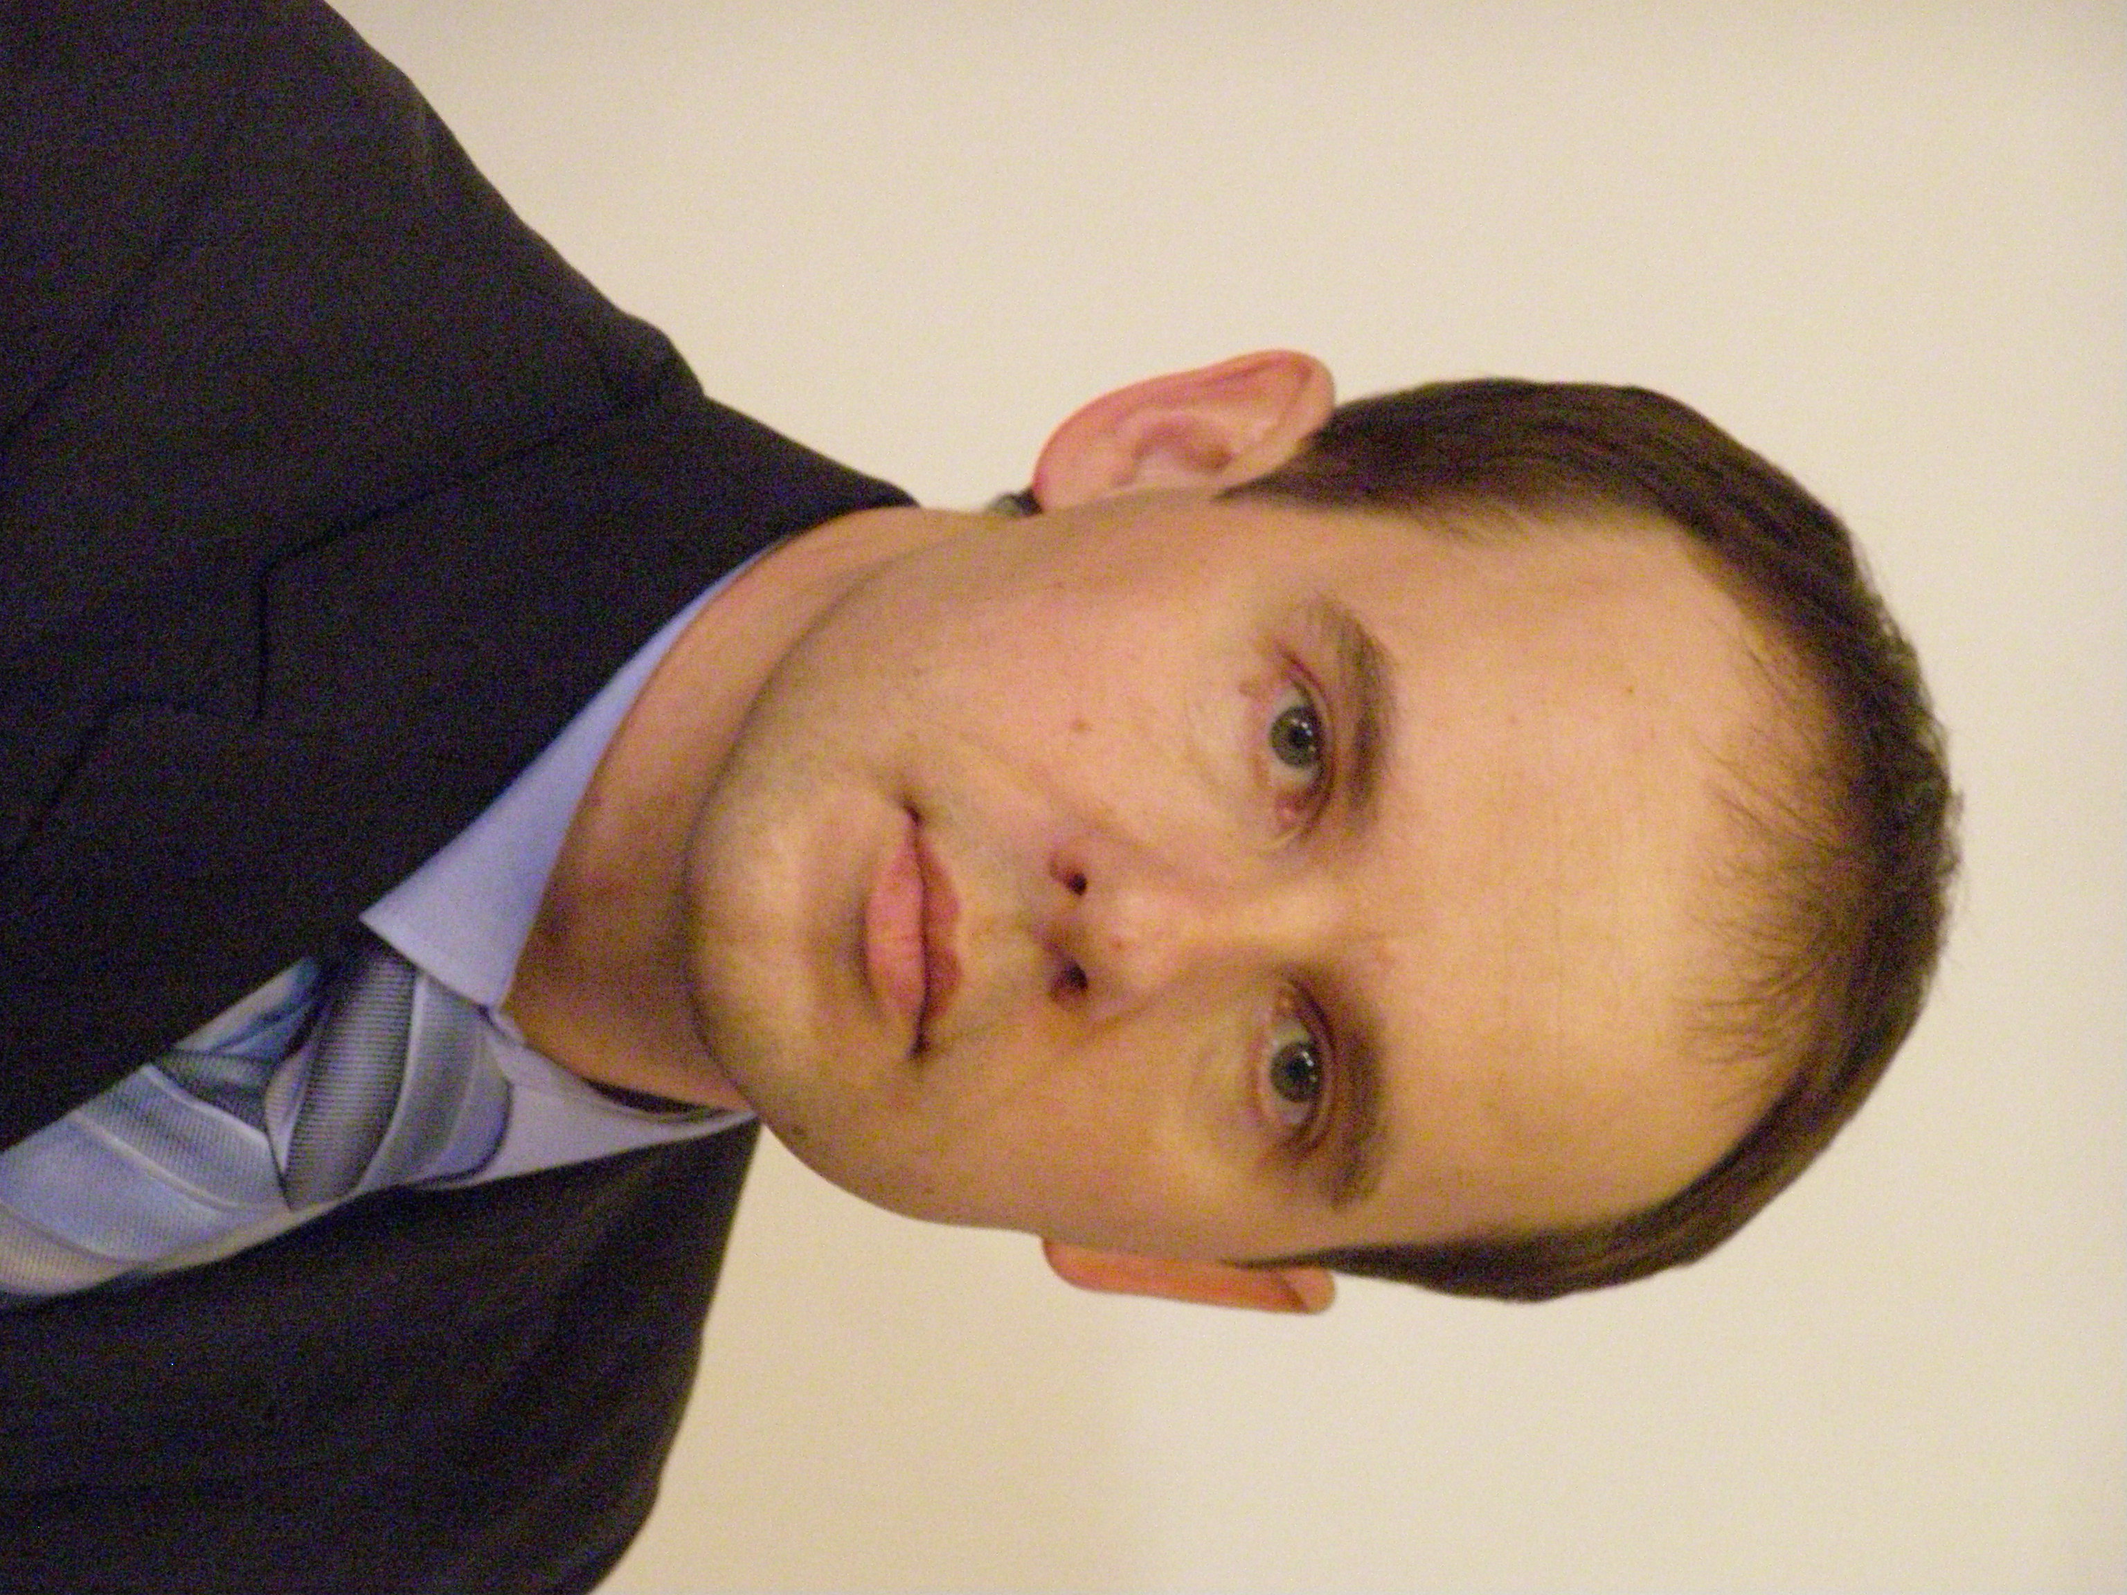
Peter Pregelj
Associate Professor, MD, PhD

Slovenia

Born in Ljubljana (Slovenia) where has graduated and obtained PhD title at the Faculty of Medicine, University of Ljubljana.
He was the National Co-ordinator for specialization in psychiatry and the Chief Mentor to the specialists in Psychiatry, Assistant Director for Education at University Psychiatric Hospital and Representative of the Slovenian Psychiatric Association in European Union of Medical Specialists (UEMS)-Section of Psychiatry.
He is the President of the Psychiatric Association of Slovenia, Associated Professor at University of Ljubljana, Faculty of Medicine (Head of the Department of Psychiatry) and Faculty of Arts, Honorary Member of the World Psychiatric Association, and the Official representative of the Psychiatric Association of Slovenia in European Psychiatric Association (EPA) Council of National Psychiatric Associations (NPAs).
Main fields of research are Neurobiology and Molecular Biology and Suicidology.
Bibliography: https://bib.cobiss.net/bibliographies/si/webBiblio/bib201_20200227_232243_18323.html

