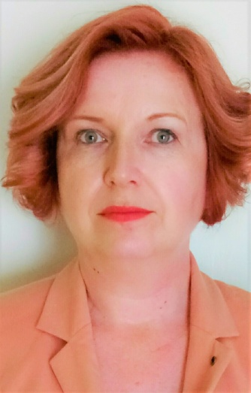
Mira Spremo

Associate Professor, MD, PhD

Bosnia and Herzegovina

Born in 1963 in Banja Luka (Bosnia and Herzegovina). Finished Gymnasium and graduated at Faculty of Medicine, University of Banja Luka. Permanently employed at University Clinical Center of Republic of Srpska Banja Luka on Psychiatric Clinic, Department of Child and Adolescent Psychiatry. After completing the specialization in Psychiatry and postgraduate studies of Children and Adolescent Psychiatry, defended the Master's Thesis entitled "Suicidal Ideas of Adolescents in Banja Luka Secondary Schools" in 2004, and the Doctoral Thesis titled "Anorexia and bulimia nervosa in adolescent population" defended in 2008 at the Faculty of Medicine, University of Sarajevo.
Completed several psychotherapy educational programs and was the author and co-author of several scientific and professional papers, as well as an associate and consultant in several projects.
Currently appointed as an Associate Professor at the Faculty of Medicine, University of Banja Luka and as the Head of the Department of Psychiatry. Also, she is a permanent consultant in the Association of Parents of Children with Autism "Djeca svjetlosti” (Children of Light) in Banja Luka.

