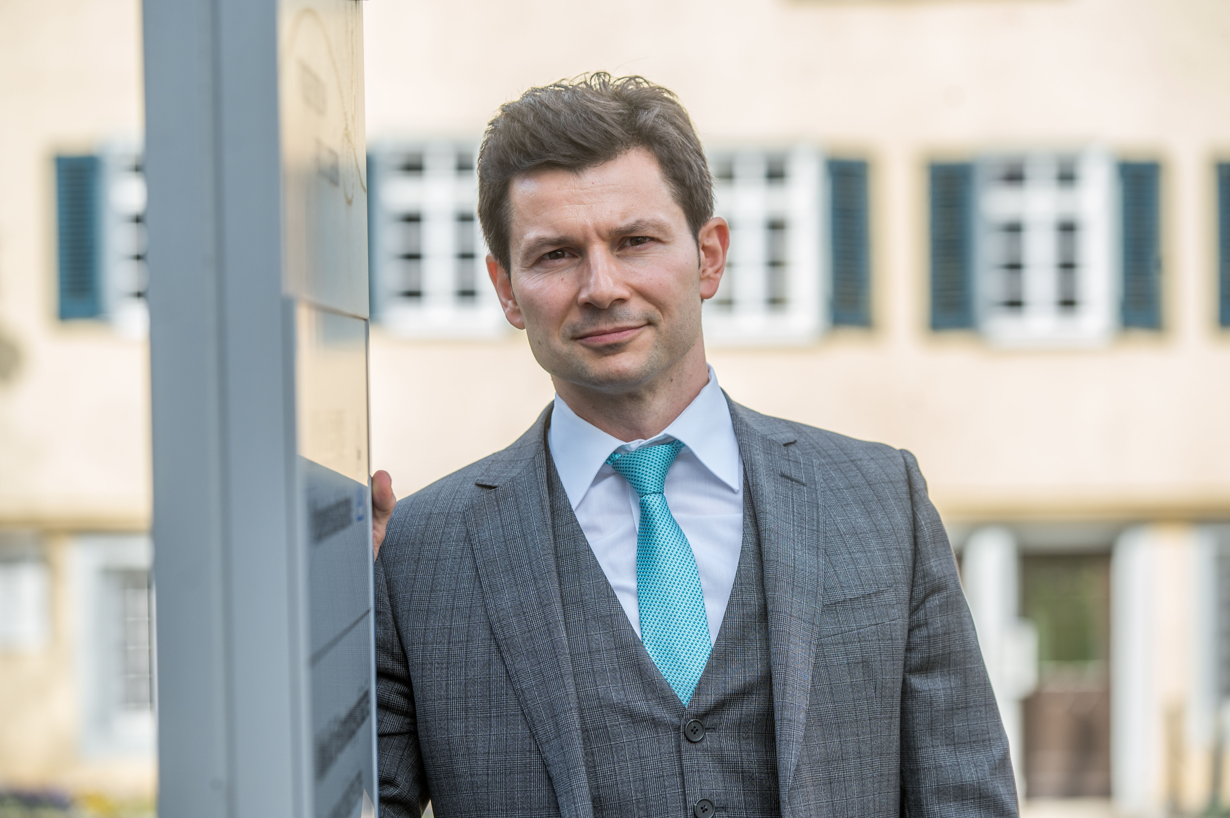
Nenad Vasić
Associate Professor, MD, PhD, MHBA, BA Phil.

Germany

Born in Belgrade (Serbia), where he visited primary school and completed the high school. From 1997 to 2003 he studied and successfully finished studies of Medicine and Philosophy at the University of Ulm (Germany). From 2004 to 2013 he worked as a clinical doctor and scientist at the University Clinic for Psychiatry and Psychotherapy in Ulm. In 2005 he completed the PhD-thesis investigating executive functions in major depression by means of functional MRI. In 2009 he completed further clinical education in psychiatry and psychotherapy with focus on cognitive behavioral therapy. Investigating differently psychiatric disorders using neuroimaging methods, in 2014 he became Associate Professor for Psychiatry and Psychotherapy at the University of Ulm. From 2014 to 2016 he worked as a Deputy Director of the University Clinic for Forensic Psychiatry, being at the same time Head of the Research Department. Since 2017 he is Medical Director of the Clinical Centre Christophsbad with about 2000 employees as well as Head of the Clinic for Psychiatry and Psychotherapy in Göppingen (Germany), comprising about 250 clinical places/beds for the treatment of inpatients. In 2019 he successfully finished the Master-studies of Business in Health Management at the University of Nuernberg.

