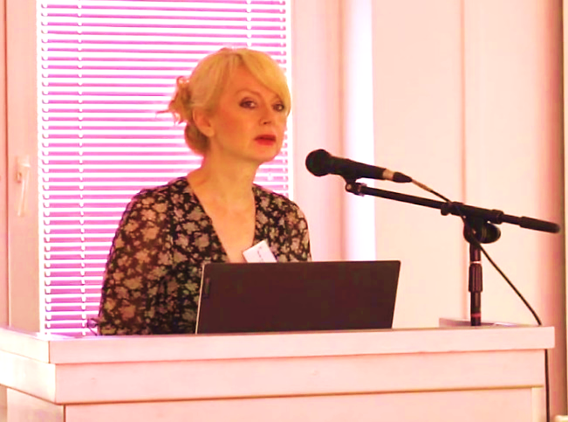
Olivera Vuković
Associate Professor, MD, PhD

Serbia

Psychiatrist, Associate Professor at the Department of Psychiatry, School of Medicine, University of Belgrade. On the same Faculty she is also Deputy of Head of Department of Specialistic Psychiatry Studies, member of the Department of Pharmacology with Toxicology (specialistic studies), and in addition she is engaged in the master’s degree Studies of Physical activity, health, and exercise therapy as well as on subspecialisation in Pain Medicine.
She obtained duties of Deputy Director and Head of the Educational Cabinet in the Institute for Mental Health in Belgrade.
She participated in numerous national and international research and published more than 200 professional and scientific papers in numerous international scientific journals. The scientific contribution of her publications is in understanding of the aetiopathogenic mechanisms of psychosomatic and affective disorders, the clinical significance of comorbidity of affective and psychotic disorders and the application of newer psychopharmaceuticals in the treatment of complex clinical manifestations of these clinical entities.
Dr Vuković is Editor in Chief of the journal Psihijatrija danas (Psychiatry Today) and a member of Editorial Board of the journal Engrami. She is Secretary General of the Serbian Psychiatric Association since 2014.

