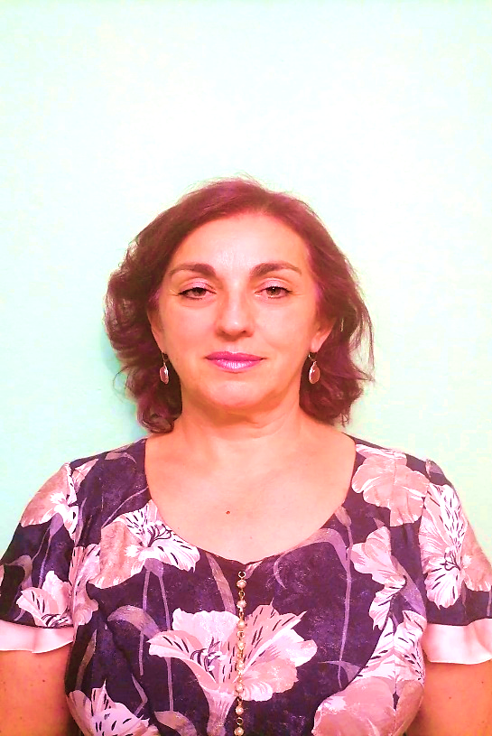
Nera Zivlak-Radulović
Associate Professor, MD, PhD

Bosnia and Herzegovina

She completed specialization in Psychiatry in 2000 at the University of Novi Sad (Serbia), and sub-specialization in Forensic Psychiatry in 2010 at the University of Kragujevac (Serbia). She obtained the scientific title of Master of Medical Sciences in 2008 and title of PhD in Medical Sciences in 2014. (both at the University of Banja Luka, Bosnia and Herzegovina).
After graduating from Faculty of Medicine at the University of Banja Luka she worked in primary health care centers in Celinac and Banja Luka (1994-1995) and since 1995 she has permanently employed at the Psychiatric Clinic, University Clinical Center of the Republic of Srpska. She became the Head of the Psychiatric Clinic in 2010. She has been a permanent court expert appointed by the Ministry of Justice of the Republic of Srpska since 2003. She was an Assistant on the Department for Psychiatry at the Faculty of Medicine, University of Banja Luka (2002–2008). Since 2004, she has been teaching at the Medical College in Prijedor where is from 2014 Professor of Mental Hygiene, and since 2021 is Professor of Mental Health in the Community and Medical Psychology and Psychiatry as well. She is an Associate Professor at the Pan-European University "Aperion" in Banja Luka, where she has been working since 2014 at the Faculty of Health Sciences as a Professor of Health Psychology and at the Faculty of Law as a Professor of Legal Medicine and Forensic Psychology and Psychopathology as well.
She is a member of the Chamber of Medical Doctors of the Republic of Srpska, as well as several professional associations in the country (Psychiatric Association of Bosnia-Herzegovina, Association of Psychiatrists of the Republic of Srpska, Association of Specialists in Addiction Diseases of Bosnia and Herzegovina). She is the President of the Association of Psychiatrists of the Republic of Srpska. She is the founder and President of the Board of Directors of the Club of Treated Alcoholics of the City of Banja Luka.
She published two books in the field of Forensic Psychiatry (Legal Medicine and Compensation for Non-Material Damages) and one book in the field of mental health prevention (Mental Hygiene). She wrote two chapters in books in the field of psychiatry and dermatology, and more than fifty professional papers and ten scientific papers in various fields of Psychiatry (especially in the field of addiction). She speaks Serbian and English.

